**Assignment 7**

**Name:** Jeevan Sai Badana

**Mail:** jeevansai100@gmail.com

**Date:** 29-01-2024

Topic: Python till exceptions

**Python Assignment**

Print Statement assign variables:

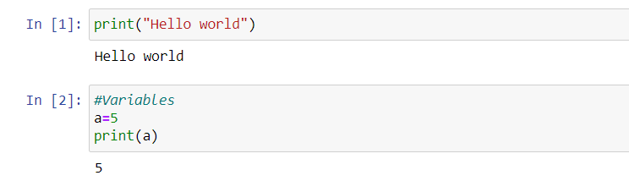

Arithmetic operators

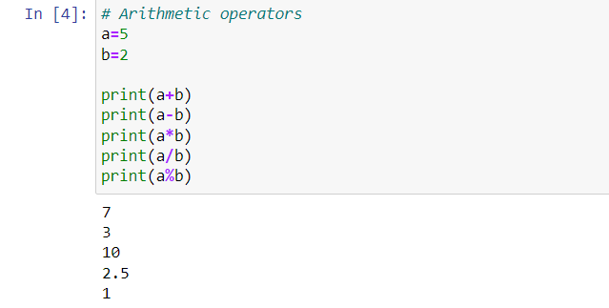

Comparison operators

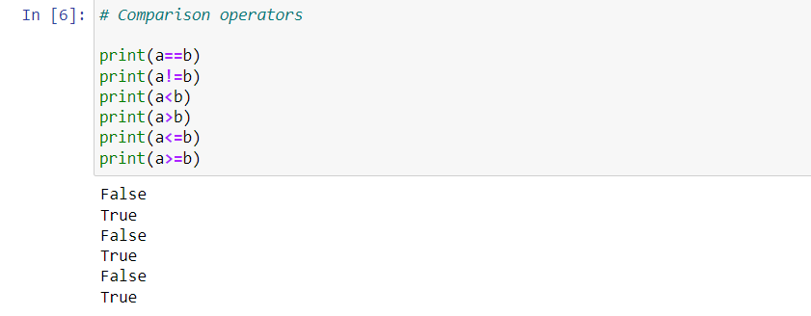

Logical operators

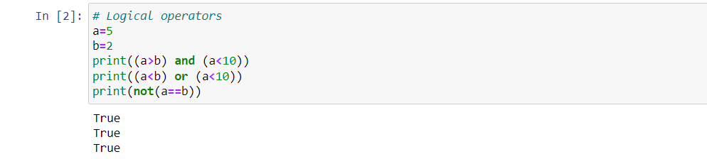

Conditional Statements

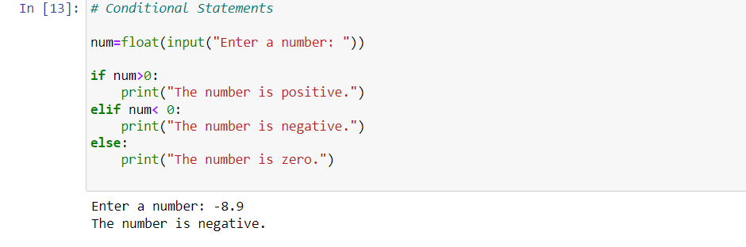

for loop

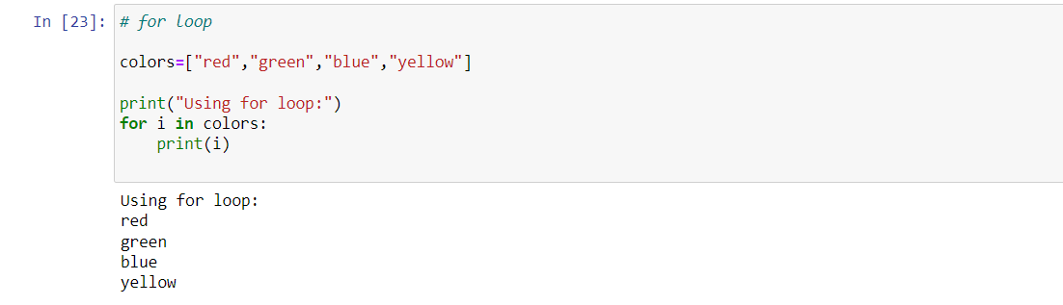

while loop

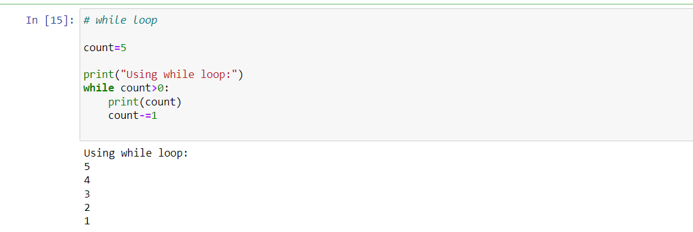

Nested loop

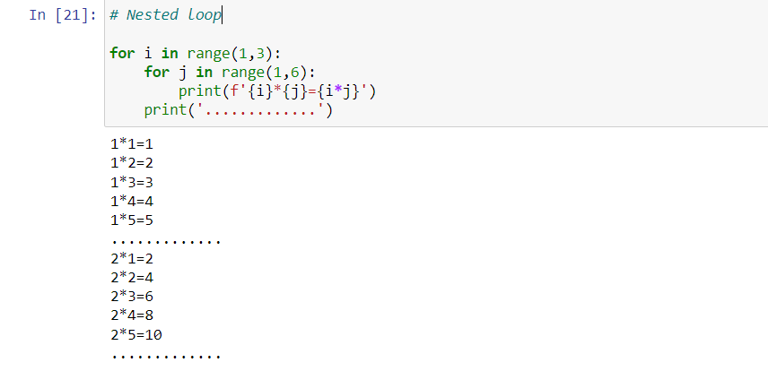

For loop example

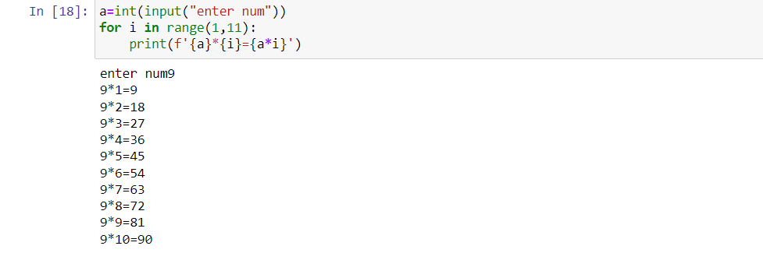

Nested while loop

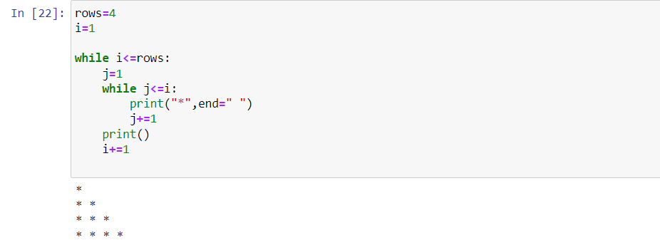

Break

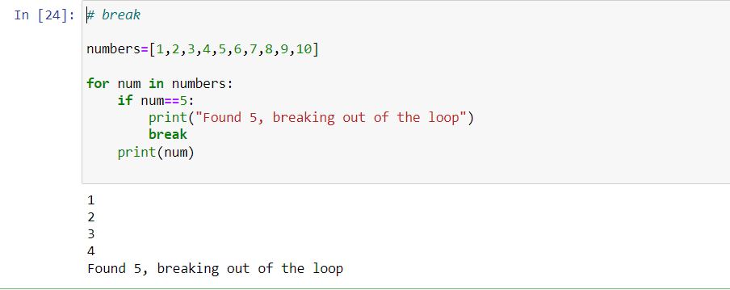

Countinue

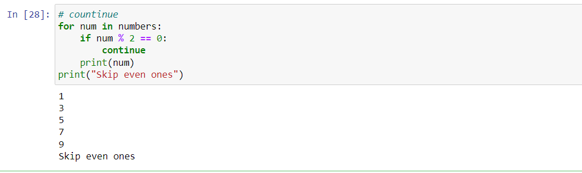

Pass

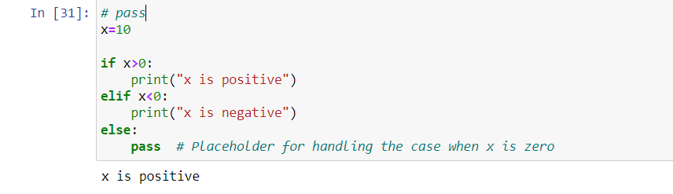

List and it functions

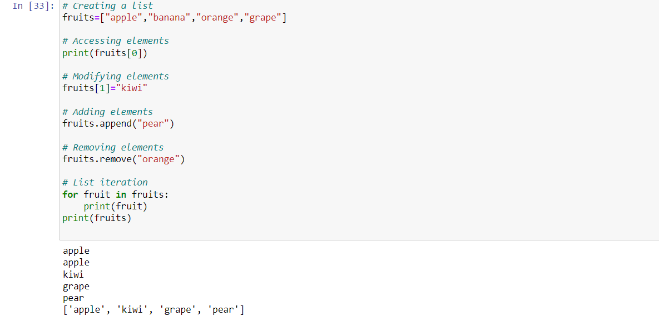

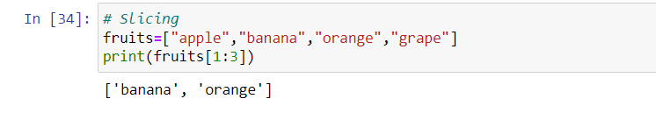

Dictionary and it functions

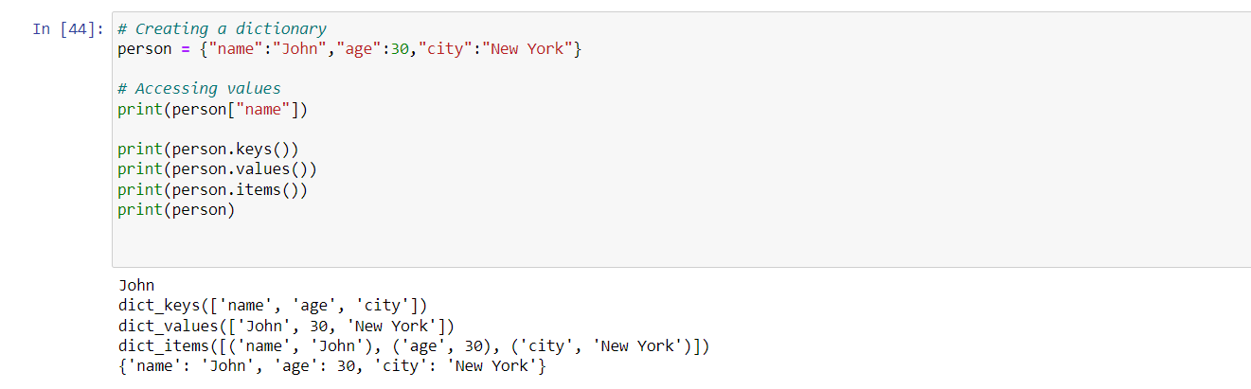

Set and it’s functions

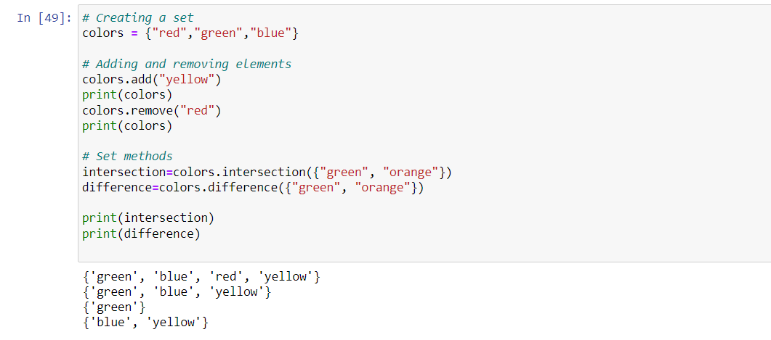

String and it’s functions

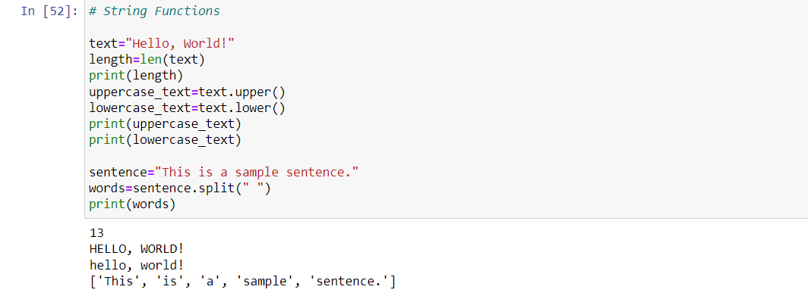

Number functions

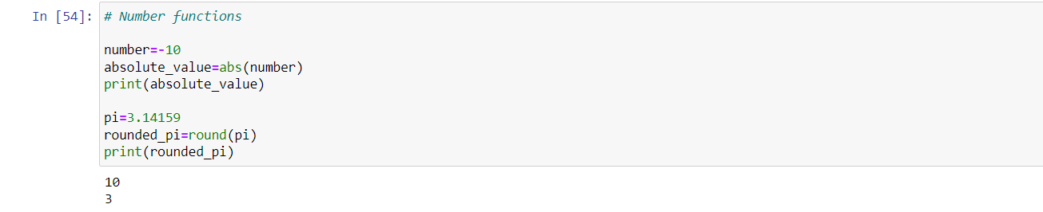

Date and time functions

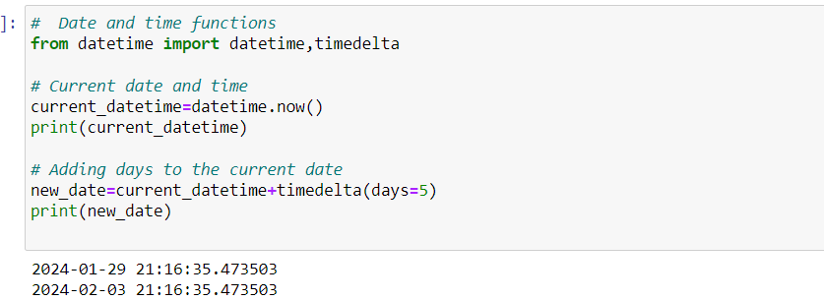

GENERAL FUN

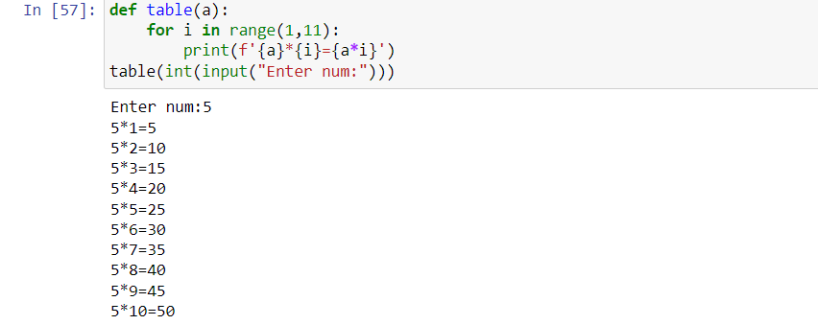

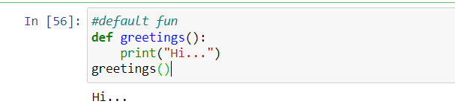

positional arguments

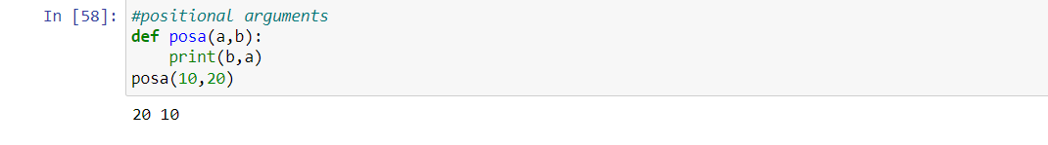

default arguments

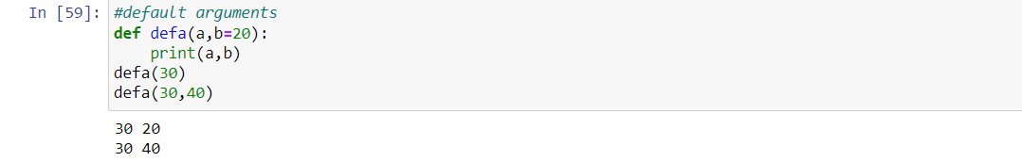

keyword arguents

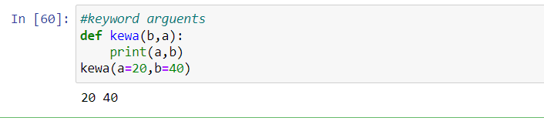

variable length positional args

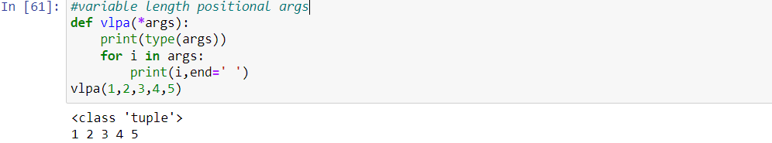

variable length keyword args

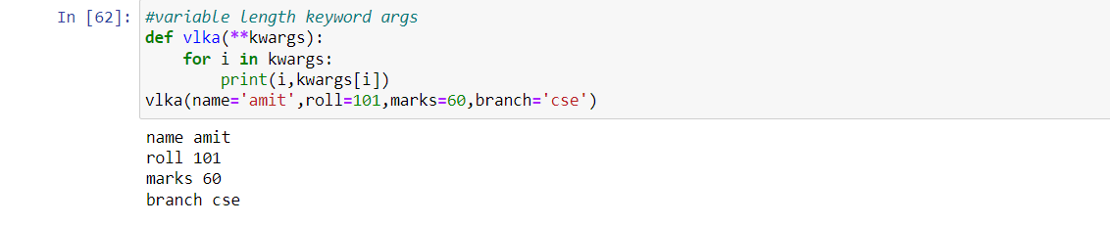

Help function

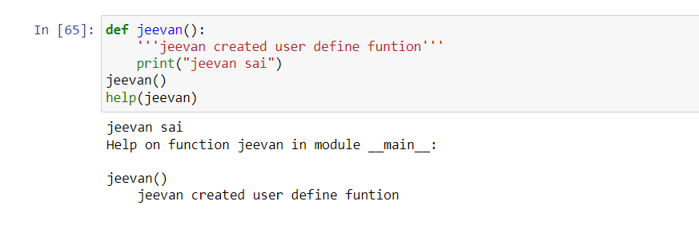

map function

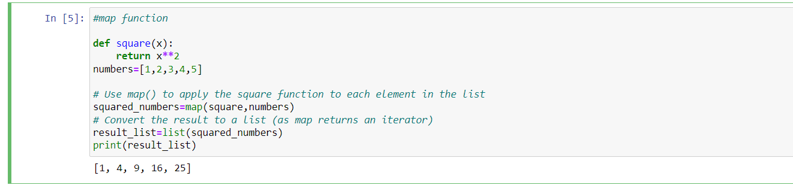

lambda function

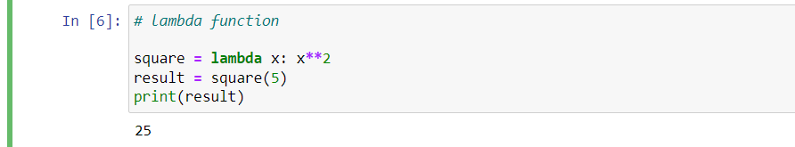

lambda + map functions

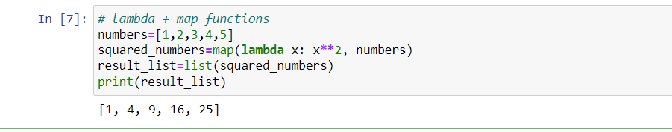

**oops concept**

class and object

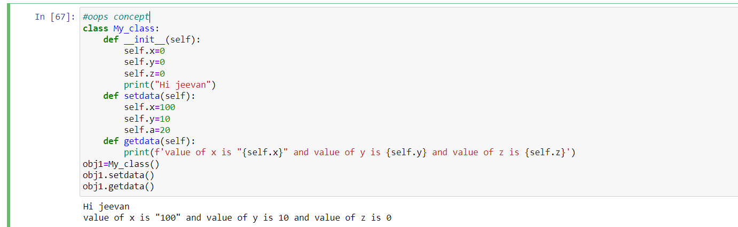

Constructor

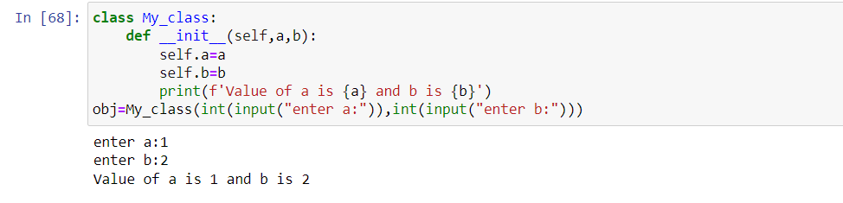

Del operator

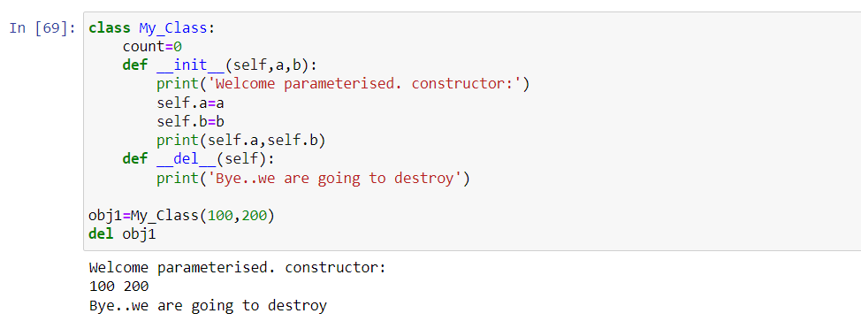

Super()

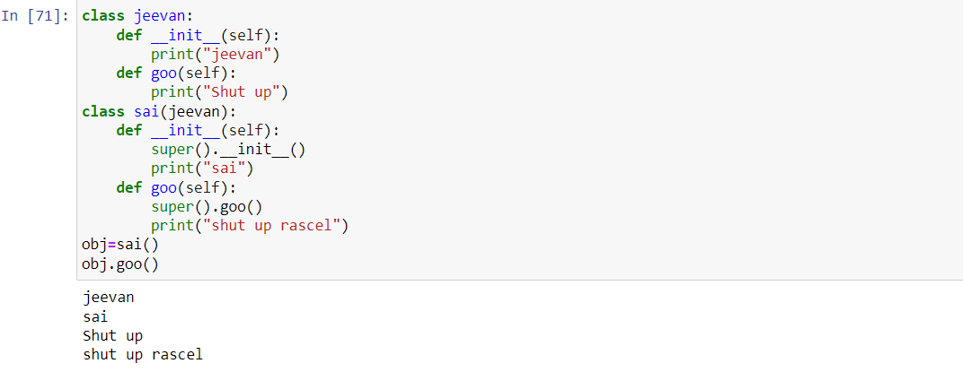

basic inheritance

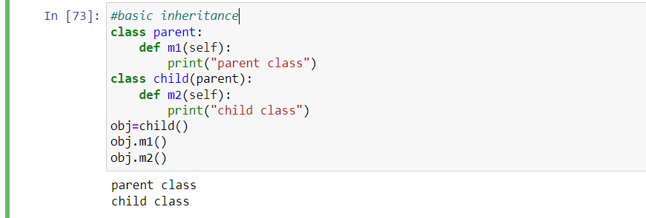

multi level Inheritence

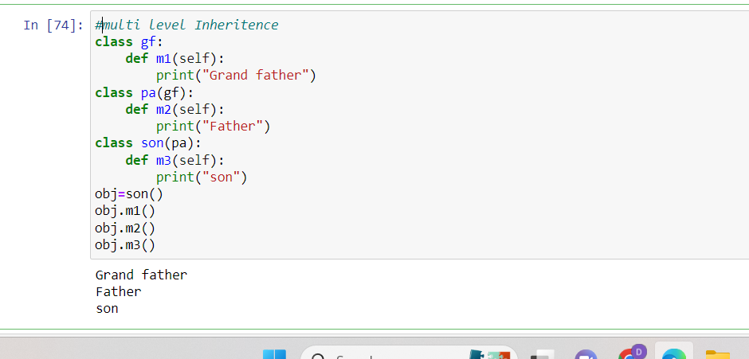

multiple inheritance

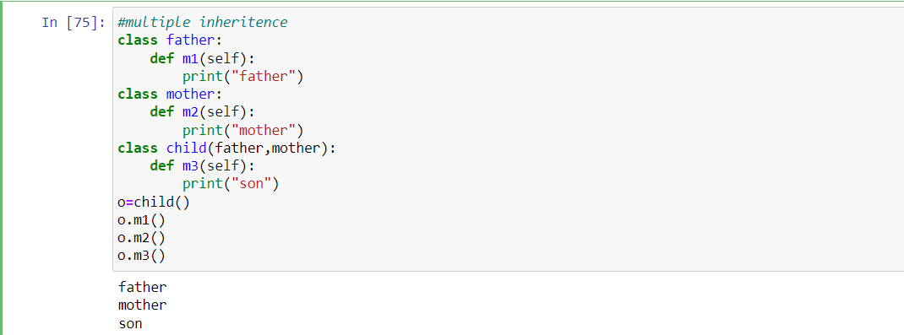

Hierarchical Inheritentence

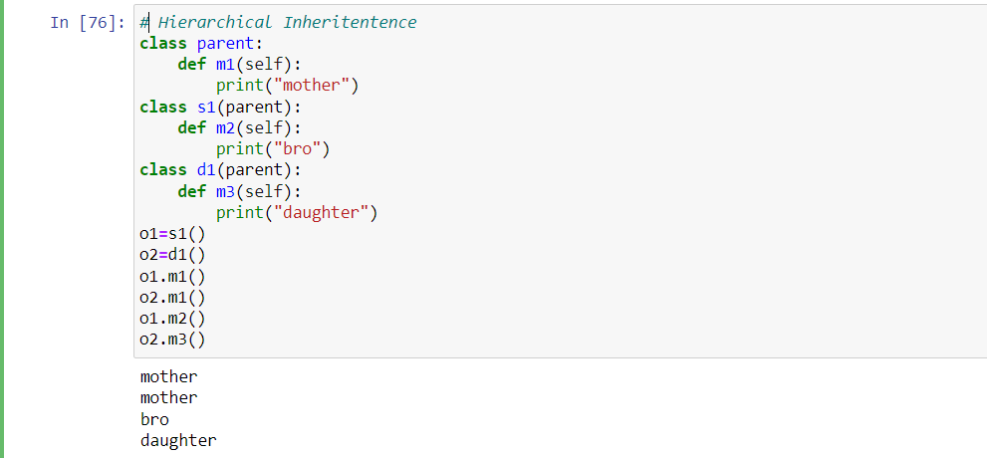

Exception handling

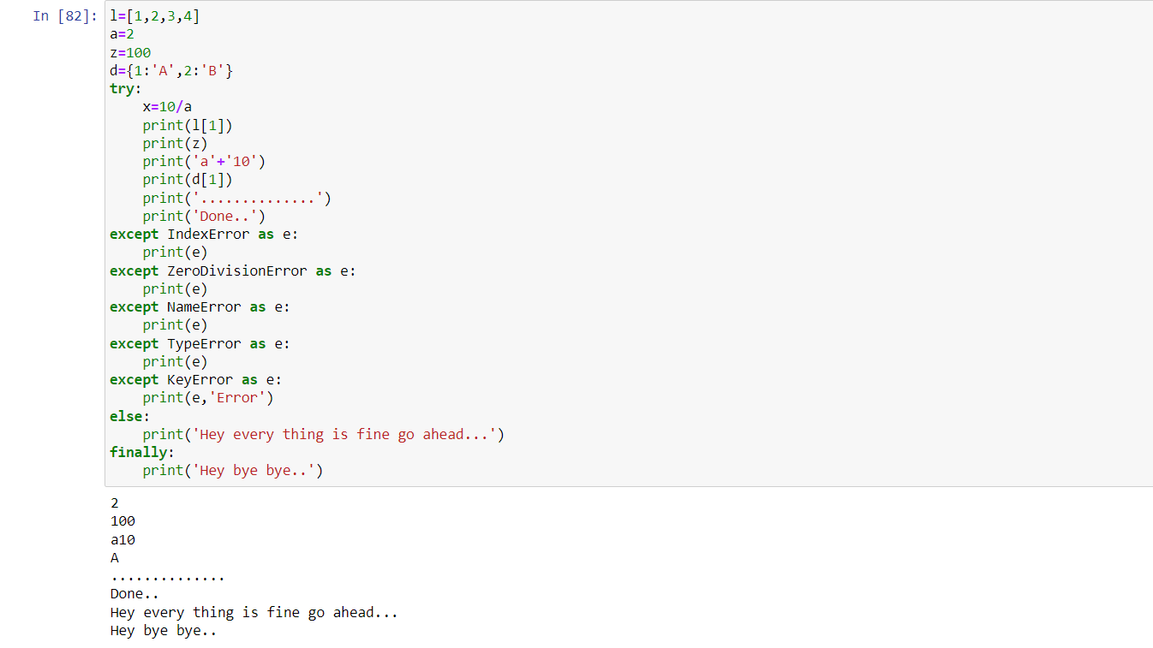

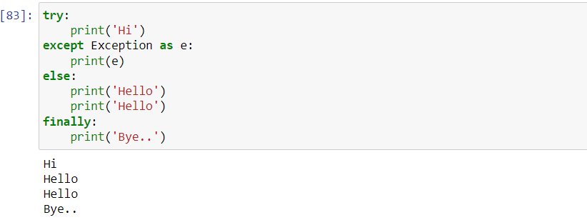

Raise exception

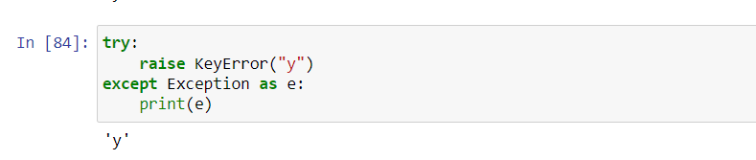

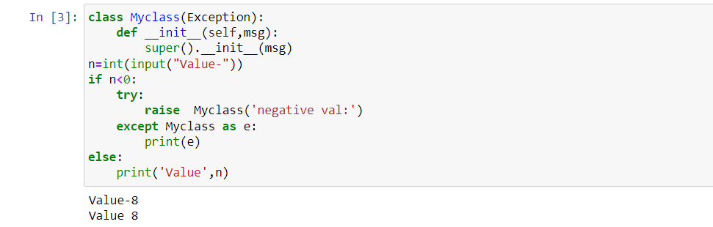

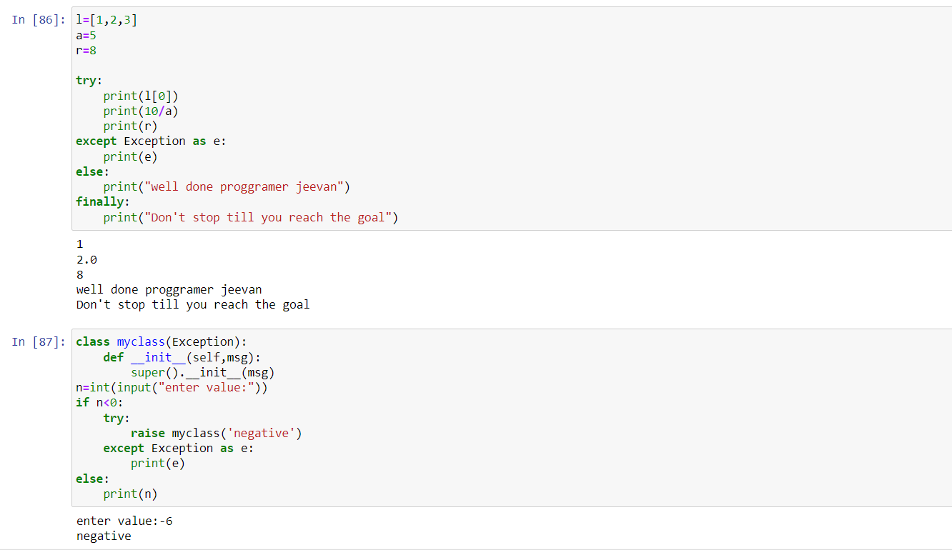

access specifiers

Public,Protected and Private

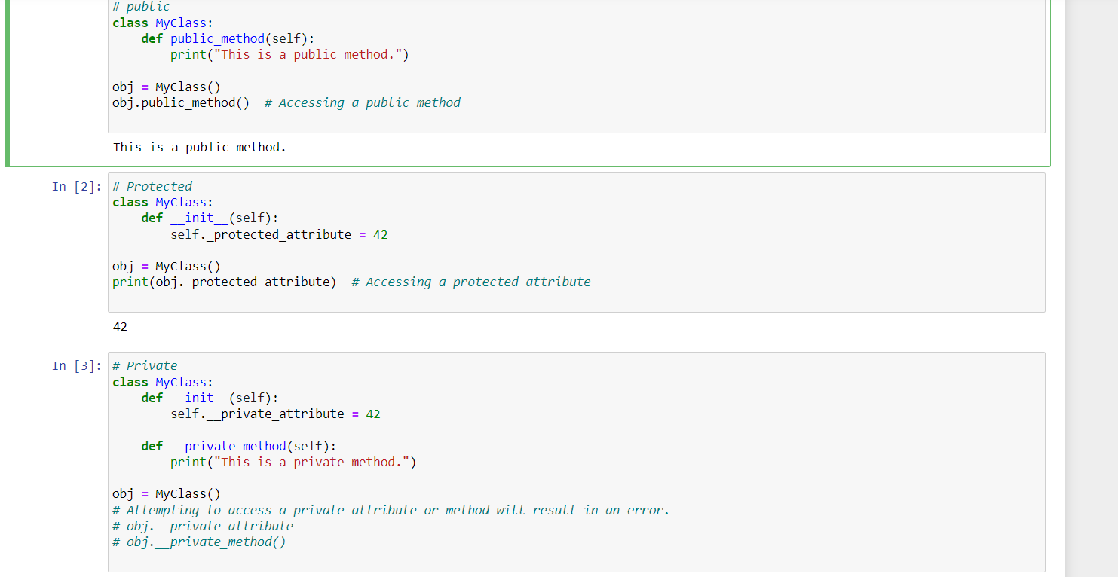

Polymorphism method overriding

